Create Node-RED Service

|  |  |
| --- | --- |
| Date | 29 october 2022 |
| Team ID | PNT2022TMID32971 |
| Project Name | IoT Based Safety Gadget for Child Safety  Monitoring & Notification |

1.To create a web application create a Node-RED service. Steps:

1. Navigated to the App creation page

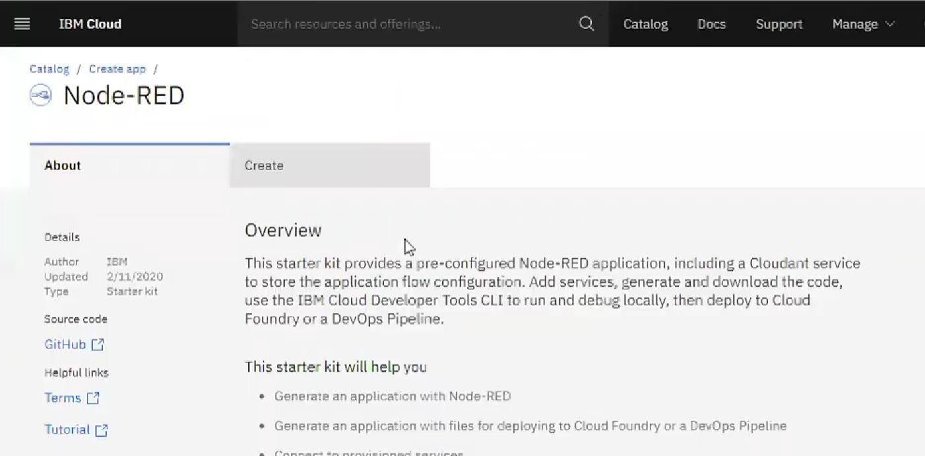

1. Enter project details and click on create

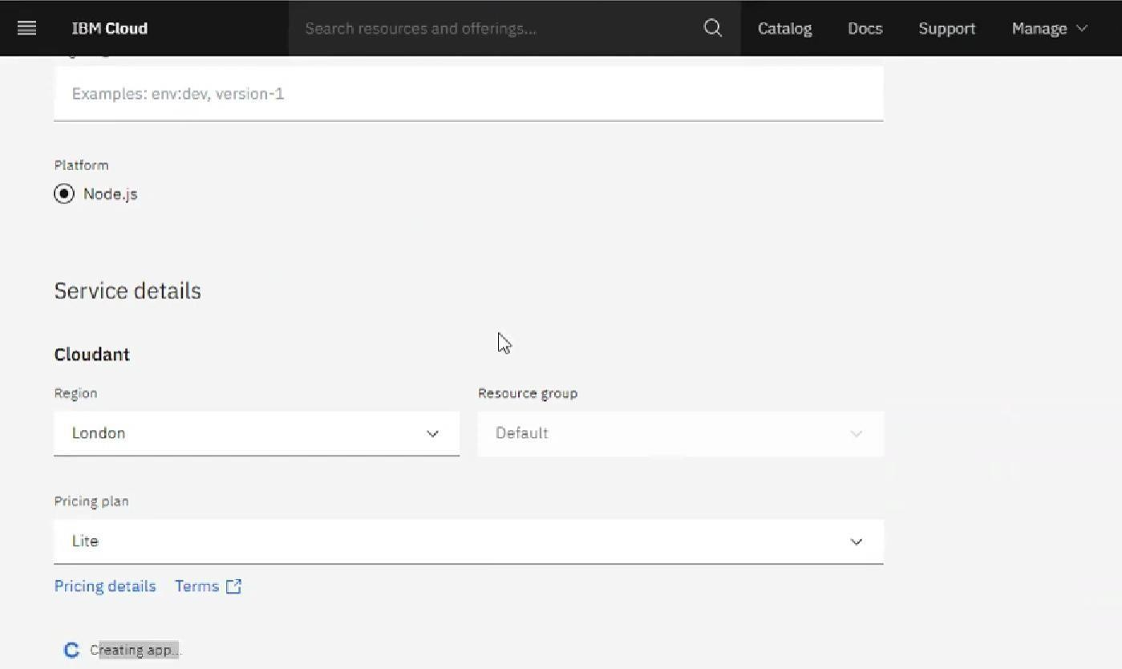

1. Click on the “Deploy your App” Button

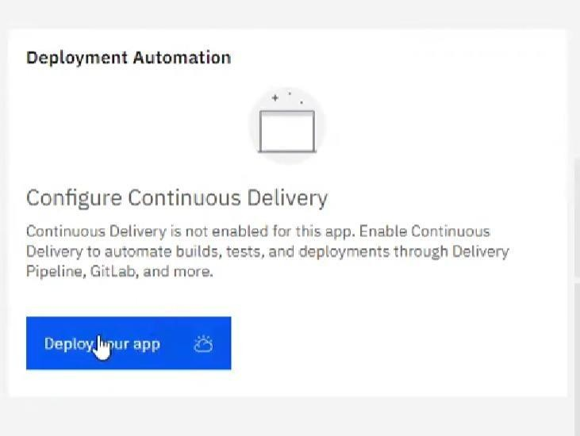

1. 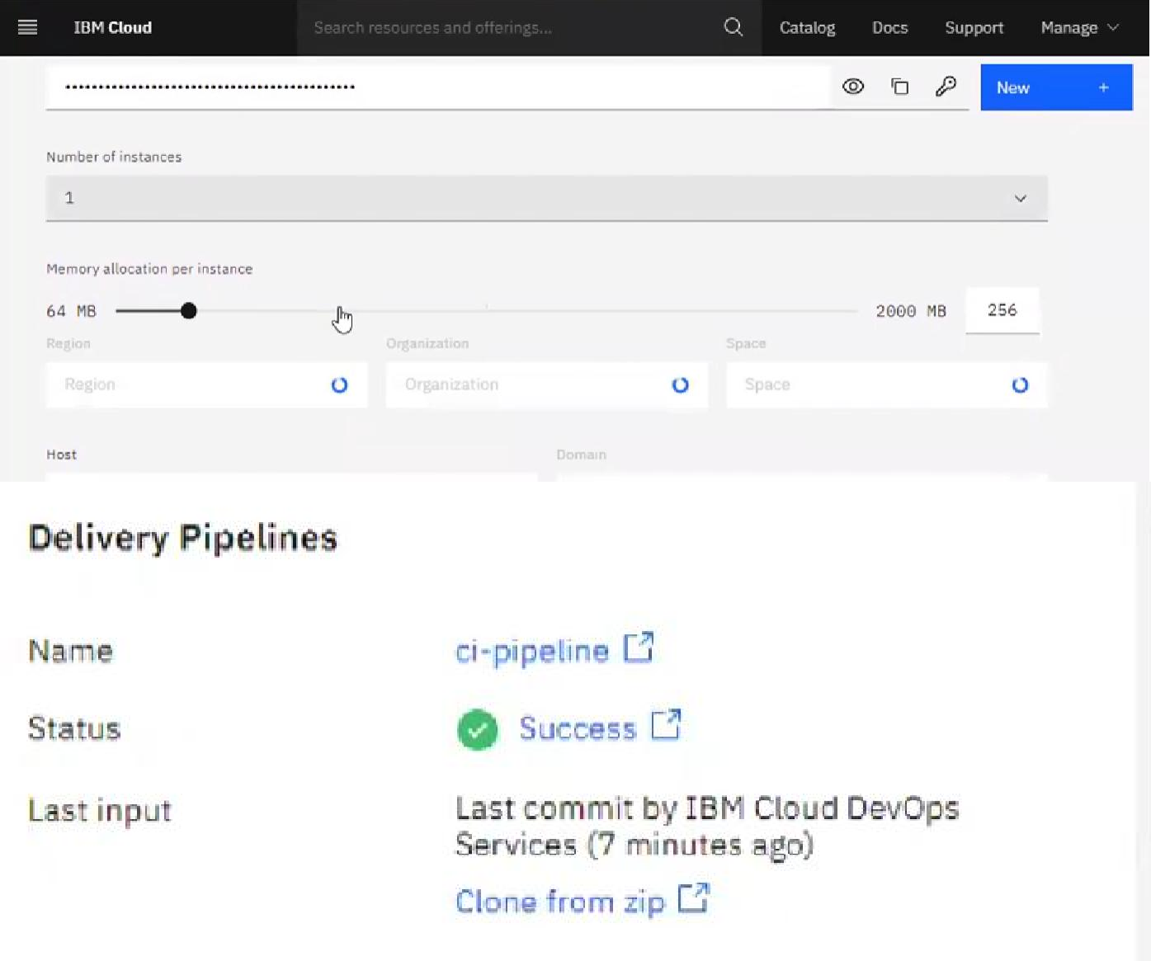Set up the environment and deploy the app
2. Instance editor and set up credentials

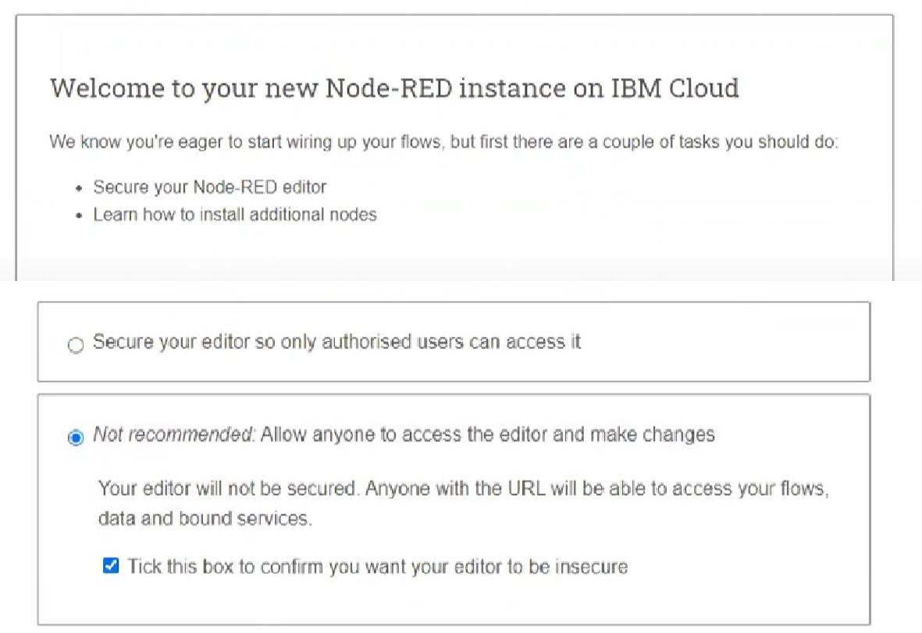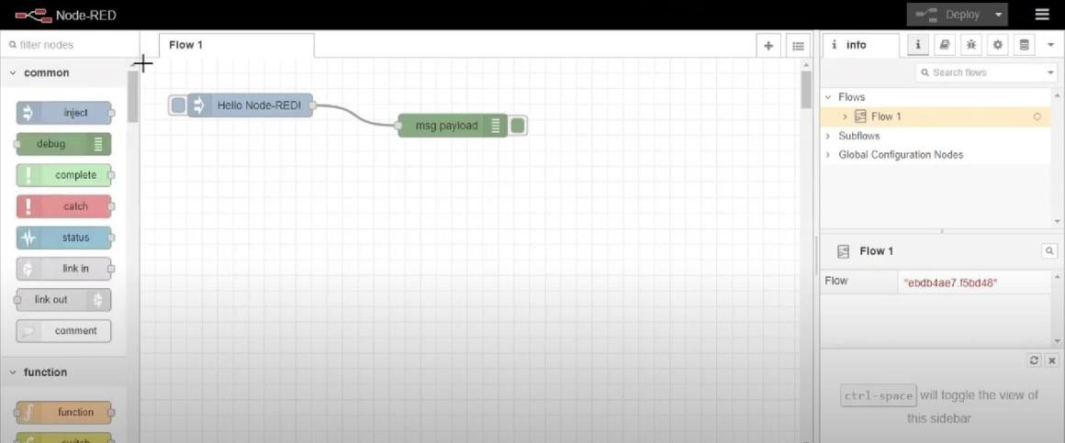

6. Drag and drop components into the editor

7. deployed the app

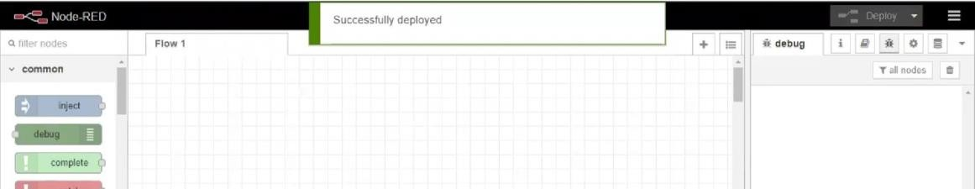

CONCLUSION:

Created a Node RED service on IBM Cloud Successfully